**Project Design Phase**

**Proposed Solution Template**

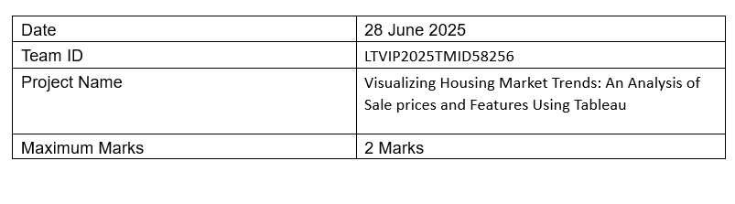

|  |  |  |
| --- | --- | --- |
| S.No. | Parameter | Description |
| 1 | Problem Statement (Problem to be solved) | Real estate analysts and stakeholders at ABC Company face difficulty identifying how house features and renovations affect sale prices due to unstructured housing data and lack of visual analysis tools. |
| 2 | Idea / Solution Description | Develop an interactive Tableau dashboard using cleaned housing data (via Tableau Prep) that visually presents KPIs, renovation effects, and feature-wise age distribution, enabling fast and confident decision-making. |
| 3 | Novelty / Uniqueness | The solution uniquely integrates data cleaning and visualization in one flow using Tableau Prep and Tableau Public, replacing manual Excel-based processes with automated, real-time visual insights. |
| 4 | Social Impact / Customer Satisfaction | Improves the efficiency and accuracy of real estate decisions, reduces analysis time, enhances communication between teams, and ensures customers (analysts, managers, and executives) have access to meaningful insights instantly. |
| 5 | Business Model (Revenue Model) | Enables ABC Company to optimize property pricing and marketing strategies, leading to higher ROI and better targeting, while also positioning the dashboard as a reusable internal analytics product. |
| 6 | Scalability of the Solution | The dashboard design is scalable for future datasets or new real estate markets. Additional features, filters, or modules can be easily added as business needs grow. |